Name: Manda Amose
In Linux, sed and awk are powerful command-line tools used for text processing and manipulation. They are very important when working with files, logs or command outputs.
Sed:
sed is primarily used for transforming text. It reads input line by line, performs an operation (like find and replace), and spits it out. It’s best when you need to make quick, global changes to a file without opening it.
- Best for: Substituting strings, deleting lines, or simple filtering.
How to Use sed:
The basic syntax for sed is:
sed [options] 'command' file
- Common Commands
- Substitution (Find & Replace): sed 's/old/new/' file.txt (replaces first occurrence per line)
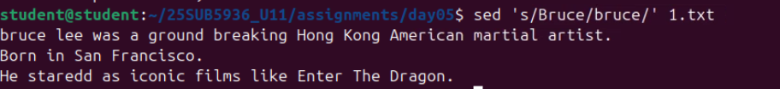
Syntax: sed 's/old/new/g' file.txt (replaces globally)

- Deleting Lines:
Syntax: sed '3d' file.txt (deletes the 3rd line)

- In-place Editing:
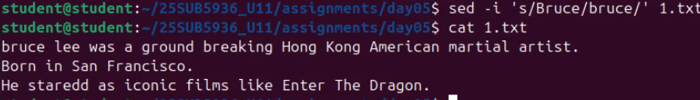
Syntax: sed -i 's/cat/dog/g' file.txt (this actually saves the changes to the file)

awk :
awk is more than just a command, it’s a full-blown programming language designed for data extraction and reporting. It views a file as a structured table with rows (records) and columns (fields).

Best for: Formatting reports, performing calculations on data, and logic-heavy text manipulation.
How to Use awk:
The basic syntax for awk is: awk 'pattern {action}' file

awk automatically breaks every line into variables: $1 is the first word, $2 is the second, and $0 is the whole line.
Common Commands:
- Printing Specific Columns:
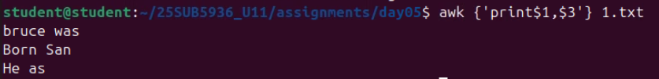
awk '{print $1, $3}' data.txt (prints only the 1st and 3rd columns)

- Filtering by Pattern:
awk '/Bruce/ {print $1}' 1.txt (prints the names of everyone in the "bruce" category)

- Math and Logic:
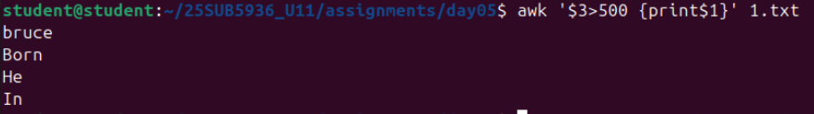
awk '$3 > 5000 {print $1}' 1.txt (prints names where the value in column 3 is over 5000)

